Wisdom Industrial AI Agent Software - User Manual

Overview
Currently, some industrial production-control software has begun to experiment with the latest AI technologies, including machine learning, machine vision, and LLMs. Applications such as equipment-maintenance Q&A and knowledge-learning tools are appearing continuously, while AI is gradually being applied to prediction, optimization, and decision-making for individual business scenarios, such as intelligent production scheduling, quality prediction, and proactive equipment maintenance. These AI applications have brought significant improvements to manufacturing operations. The deep integration of AI into industrial software has become a clear trend.
Smart manufacturing is a complex, integrated systems-engineering discipline, and intelligent industrial software is one of its core components. The business processes supported by intelligent production-control software require AI capabilities. However, production-control software itself is still largely a traditional information system and lacks inherent intelligence, making it difficult to achieve business collaboration through the system or to support decision-making for complex business scenarios. AI applications are gradually expanding into vertical domains. Technical experiments have begun to place AI agents at the center of information systems across vertical industries, but truly general-purpose and extensible products with proven business implementations are still rare.
In our earlier work, we conducted preliminary research and built a prototype system for unstructured-text processing by combining large language models with RAG. However, industrial environments contain many information systems and large volumes of structured data, which are often exposed through services. The goal of Wisdom Industrial AI Agent Software is to use a more intelligent approach that supports both unstructured text and structured information-system data, making AI smarter and more accurate in industrial applications.
This document is the system user manual for Wisdom Industrial AI Agent Software. It explains the basic use of the software through the following sections: Home, Model Management, Agent Creation, Agent Orchestration, and Agent Publishing and Integration.

Software Home
After logging in, the Home page displays a list of created agents. The Home page is the entry point for all applications and provides basic application operations. By default, all agents are displayed. Click Chat Assistant to filter and display all chat assistants, or click Workflow to display all workflows. Enter an agent name in the search box to quickly find it.
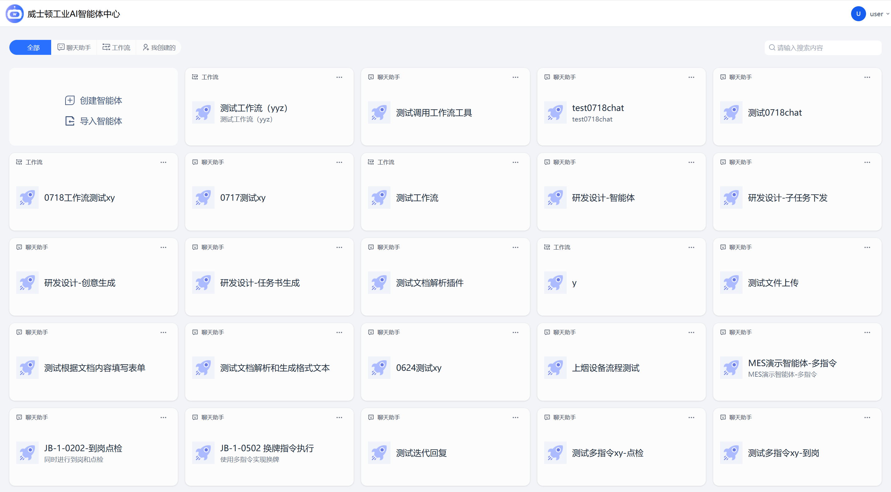
Software Home
Hover over an application card and click the button in the upper-right corner to display detailed operations for the application, including Edit, Open, Export, and Delete. Click “Edit Information” to open the agent information dialog, where you can modify the agent’s name, description, and icon. Click “Save” to save changes or “Cancel” to discard them. Click “Open” to open the agent chat-assistant page. Click “Delete” to display a deletion-confirmation dialog.
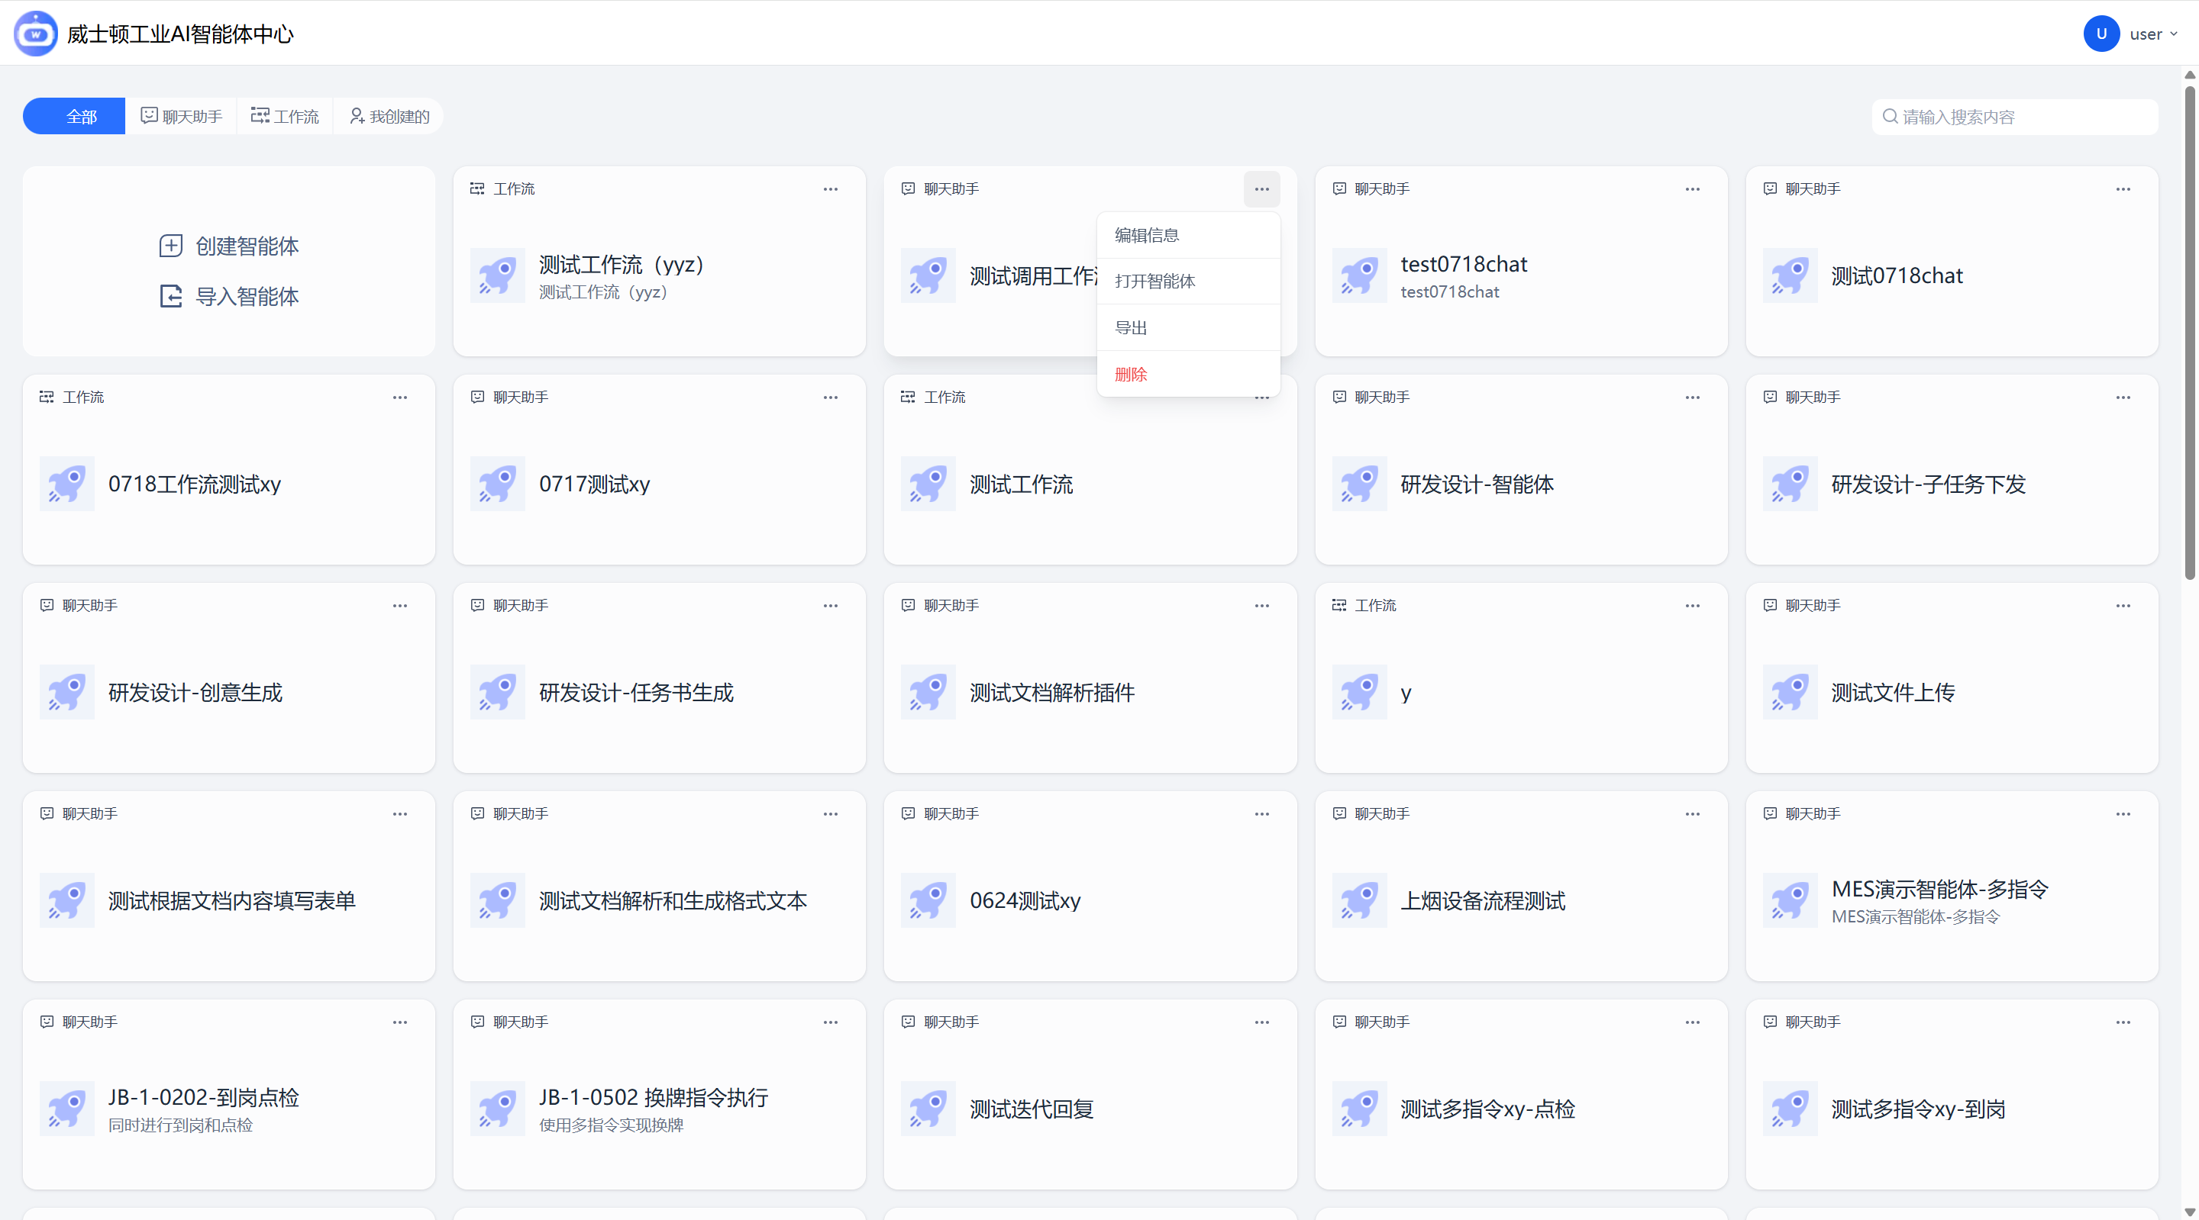
Operations Menu

Model Management
From the Settings menu on the Home page, you can enter the Model Management module. This module is primarily used to manage model configurations required by subsequent large-model nodes and by the system defaults.
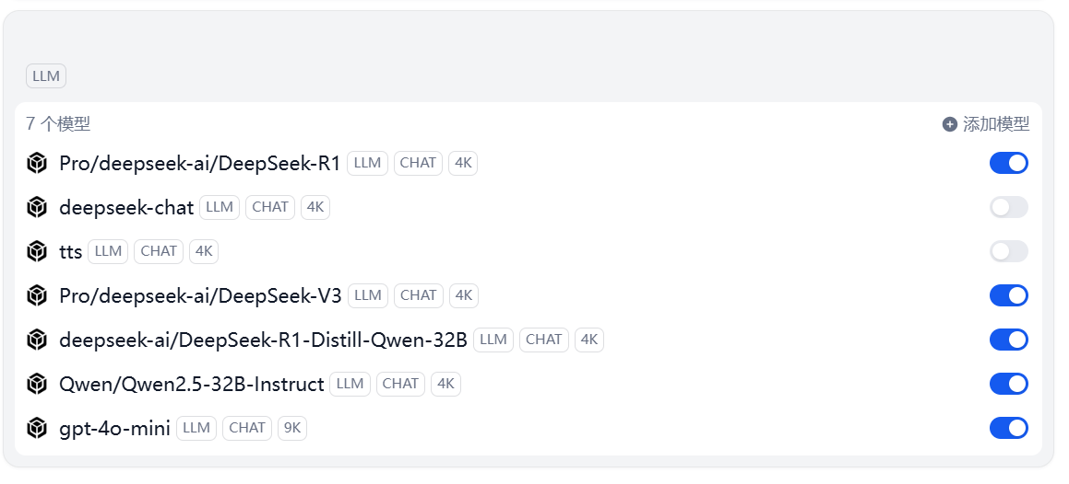
Model Management List
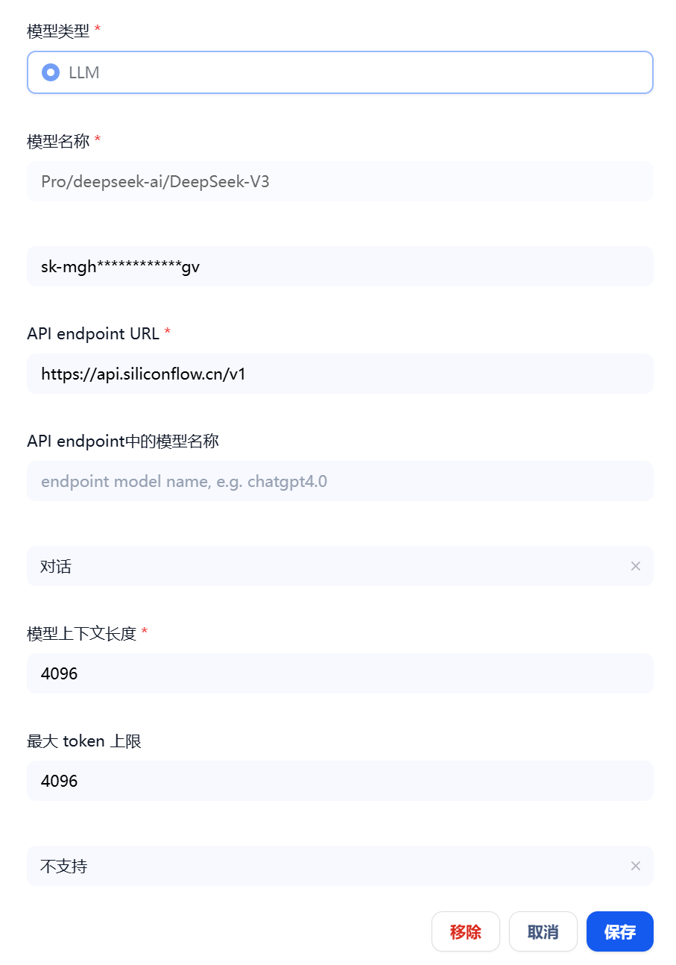
Model Editing

Agent Creation
On the Home page, click “Create Agent” to open the creation page. The system supports creating chat assistants for complex multi-turn conversations as well as orchestrated workflows for single-turn automated tasks. A chat assistant uses workflow orchestration to implement complex multi-turn conversations and supports memory; a workflow uses workflow orchestration to execute complex single-turn automated tasks.
To create an agent, you must enter an agent name. This field is required. You may also enter an agent description. Click “Create” to create the agent and enter its orchestration page, or click “Cancel” to cancel creation and return to the Home page.
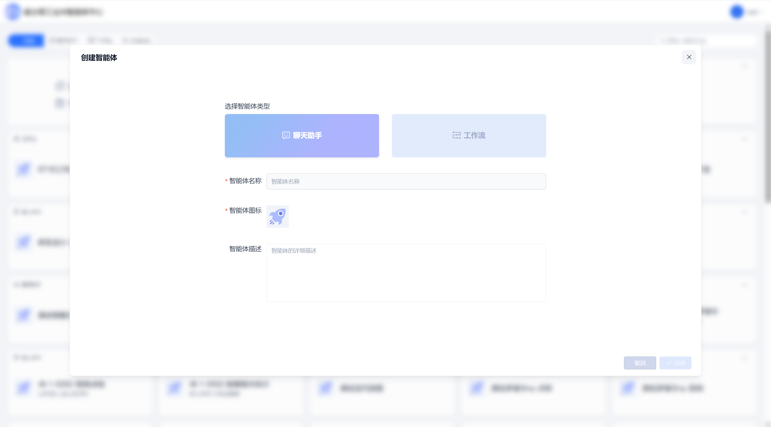
Agent Creation

Agent Orchestration
Agent orchestration includes adding, configuring, and deleting nodes, as well as previewing the agent.
On the Agent Orchestration main page, the toolbar on the left is used to create various process nodes, operate the overall canvas, and configure global agent settings. The center area is the main canvas used to edit and display the process. The right side shows configuration details for each node, allowing detailed node configuration so that the agent’s overall execution logic can be designed. See the figure below:
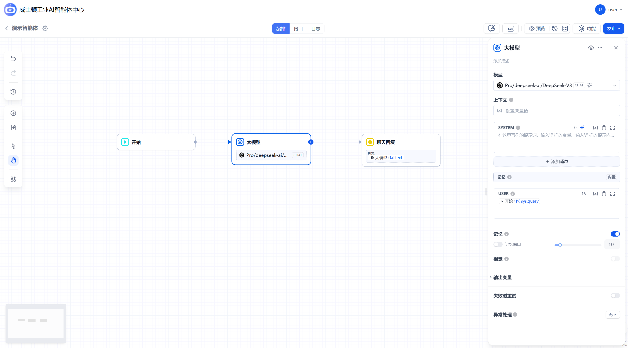
Agent Orchestration Main Page
The following sections provide detailed explanations of nodes and agent preview.

Nodes
Node operations include adding nodes, configuring nodes, and editing nodes.
- Add Node: Click “Add Node” in the orchestration workspace to add a node. You can also click the add icon on the connection line between two nodes. Available node types include Large Model, Chat Reply, Conditional Branch, Multiple-Instruction Execution, Code Execution, Variable Assignment, HTTP Request, Wisdom Assistant Knowledge Base Retrieval, Send Instruction, and Call Agent. See the figure below:
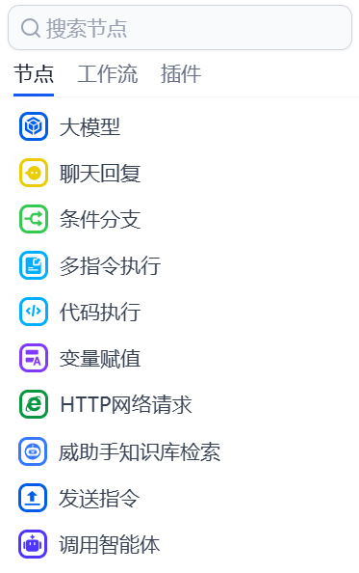
Node List
- Configure Node: Select a node to display its configuration panel. You can add a description and configure detailed node information. For example, for a Large Model node you can select the model, set context and memory values, define output variables, enable or disable retry on failure, and configure exception handling.
- Edit Node: Right-click a node to run, modify, copy, duplicate, or delete it.
As shown below:
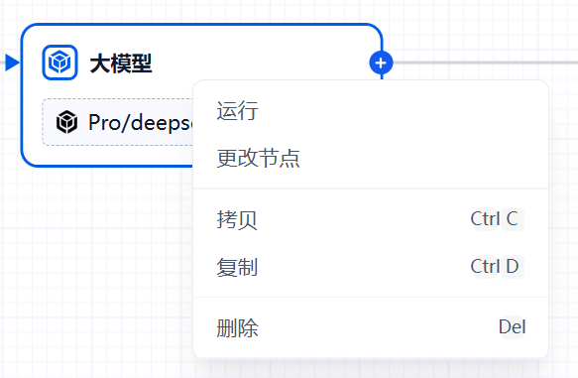
Detailed descriptions of each node type are provided below:

Large Model Node
This node is used to configure connections to and use of large language models.
Large Model Node - Overall Interface
Configurable information includes:
- Large Model Selection: Select a local or cloud-based large model;
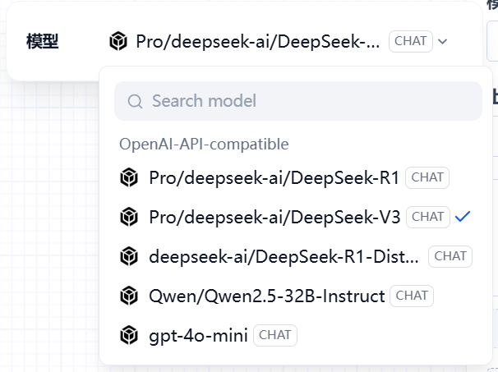
Large Model Node - Model Selection
- Prompt Configuration: Configure system and user prompt information;
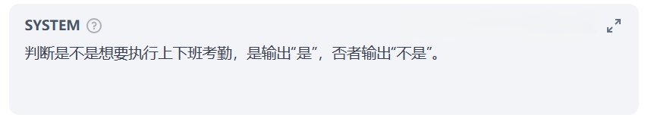
Large Model Node - Prompt Settings
- Large Model Memory Scope: Configure the range of contextual data that the large model can remember;
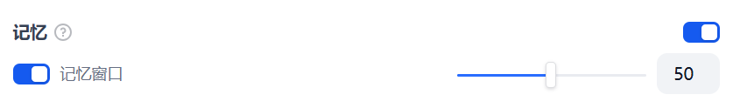
Memory Settings
- Output Variables: Displays the names and types of variables output by the large model.
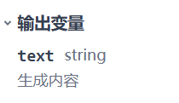
Output Variables

Conditional Branch
This node determines the branch direction of a process based on specified conditions. Multiple conditions can be configured using standard if / elseif / else combinations to connect to multiple downstream process branches.
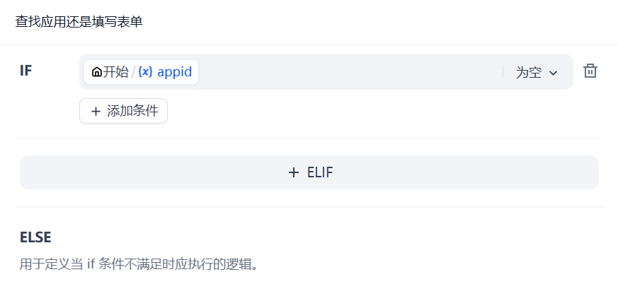
Condition Configuration

Multiple-Instruction Execution
This node is used to execute multiple instructions simultaneously or sequentially. It can be configured by passing an array containing multiple instructions.
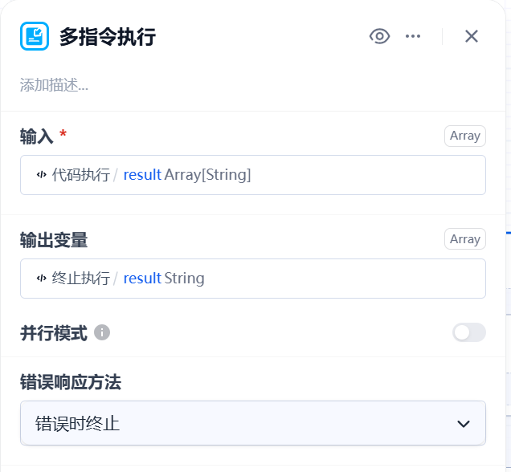
Multiple-Instruction Execution Settings

Code Execution
This node executes a predefined code segment based on input variables and outputs the execution result to the next node. The supported programming language is JavaScript.
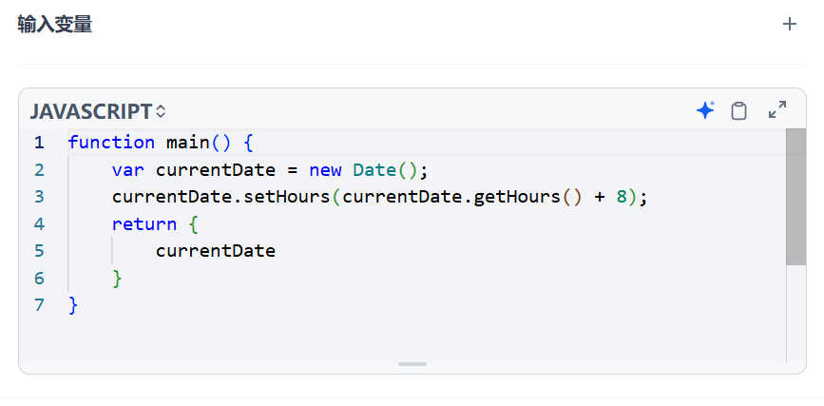
Code Editing
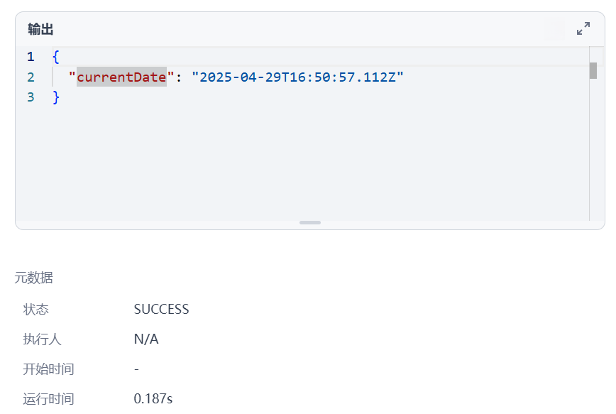
Code Execution

Variable Assignment
This node can operate on process session variables, including modifying, clearing, and assigning values to them.
As shown below:
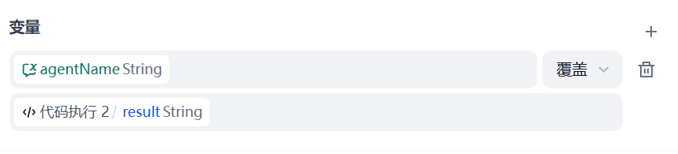
Variable Assignment Configuration

HTTP Request
This node can configure general HTTP requests. Features include:
Import settings based on cURL;
Request URL settings supporting RESTful methods including POST, GET, HEAD, PATCH, PUT, and DELETE;
Detailed HEADERS configuration;
Request parameter configuration;
BODY type and value configuration;
Timeout configuration;
Failure retry count and retry interval configuration.
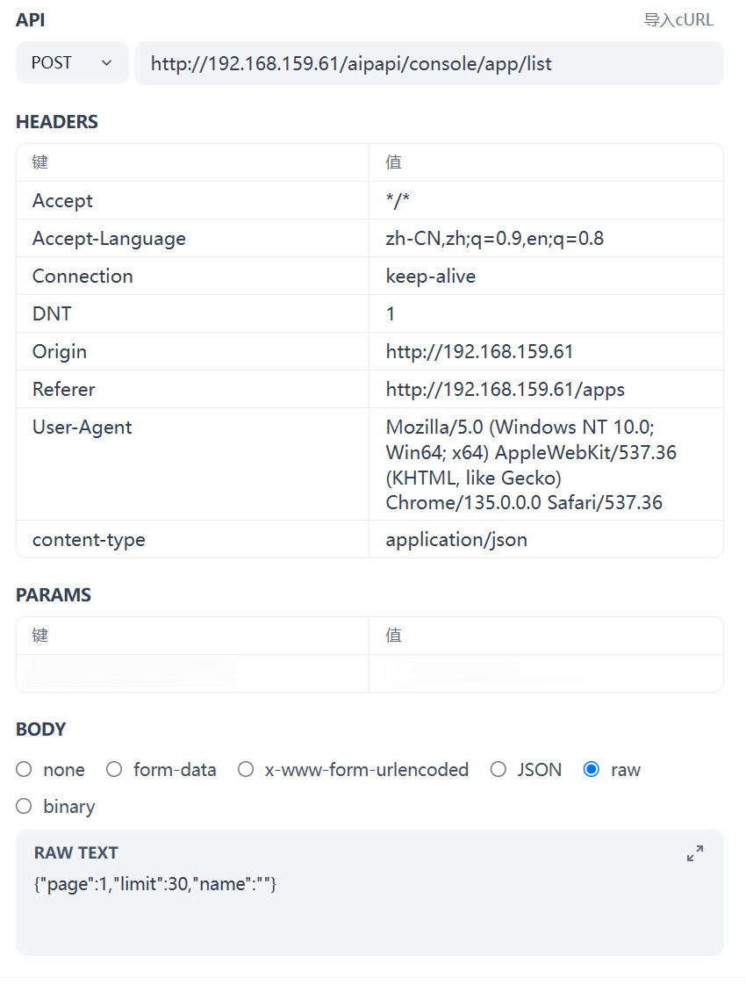
HTTP Request Configuration

Wisdom Assistant Knowledge Base Retrieval
This node configures retrieval from the Wisdom Assistant knowledge base. By selecting a knowledge base, the workflow can query the Wisdom Assistant knowledge base and obtain the returned RAG retrieval results.
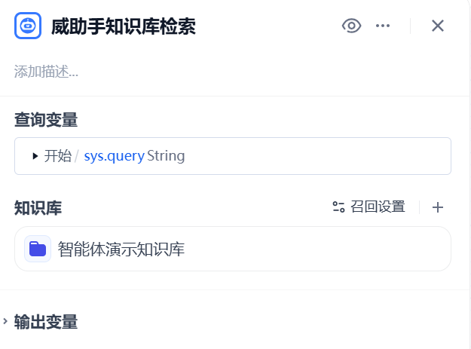
Wisdom Assistant Knowledge Base Retrieval Configuration

Chat Reply
This node configures the final information returned to the user. It can be set to a variable value or a fixed value.
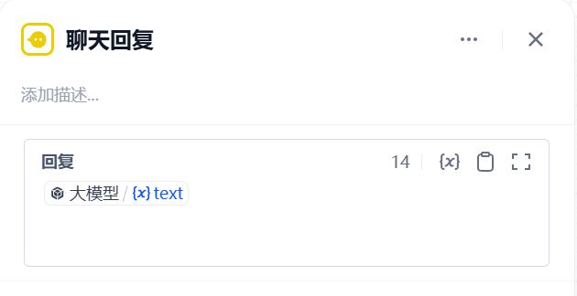
Direct Reply Configuration

Send Instruction
This node configures a specific instruction to be sent again to an agent during a workflow. The instruction can be set to a variable value or a fixed value, and agent input parameters can also be configured.
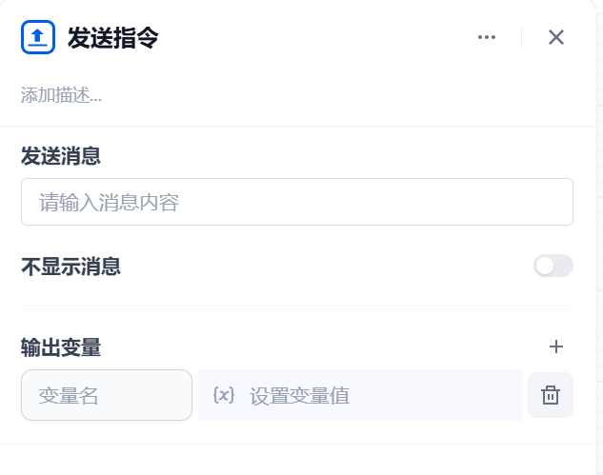
Send Instruction Configuration

Call Agent
This node is used to call another agent within a workflow. You can select any agent that has been published in this system.

Call Agent Configuration

Preview
Click the “Preview” button to open the preview dialog. Enter content in the input box to chat with the bot and preview the response.
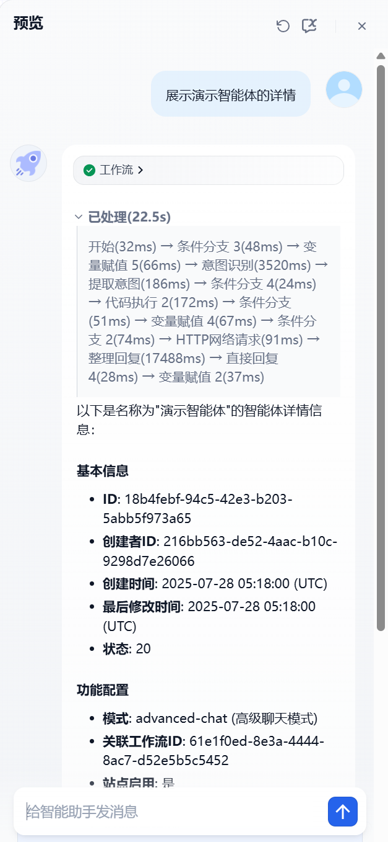
Preview Result

Agent Publishing and Integration
Click the “Publish” button to publish the agent.
Currently, an agent can be published as a chat-assistant feature embedded in a web page. This software provides an integration API that allows agents to be integrated at the code level with existing industrial systems, enabling various interaction scenarios.
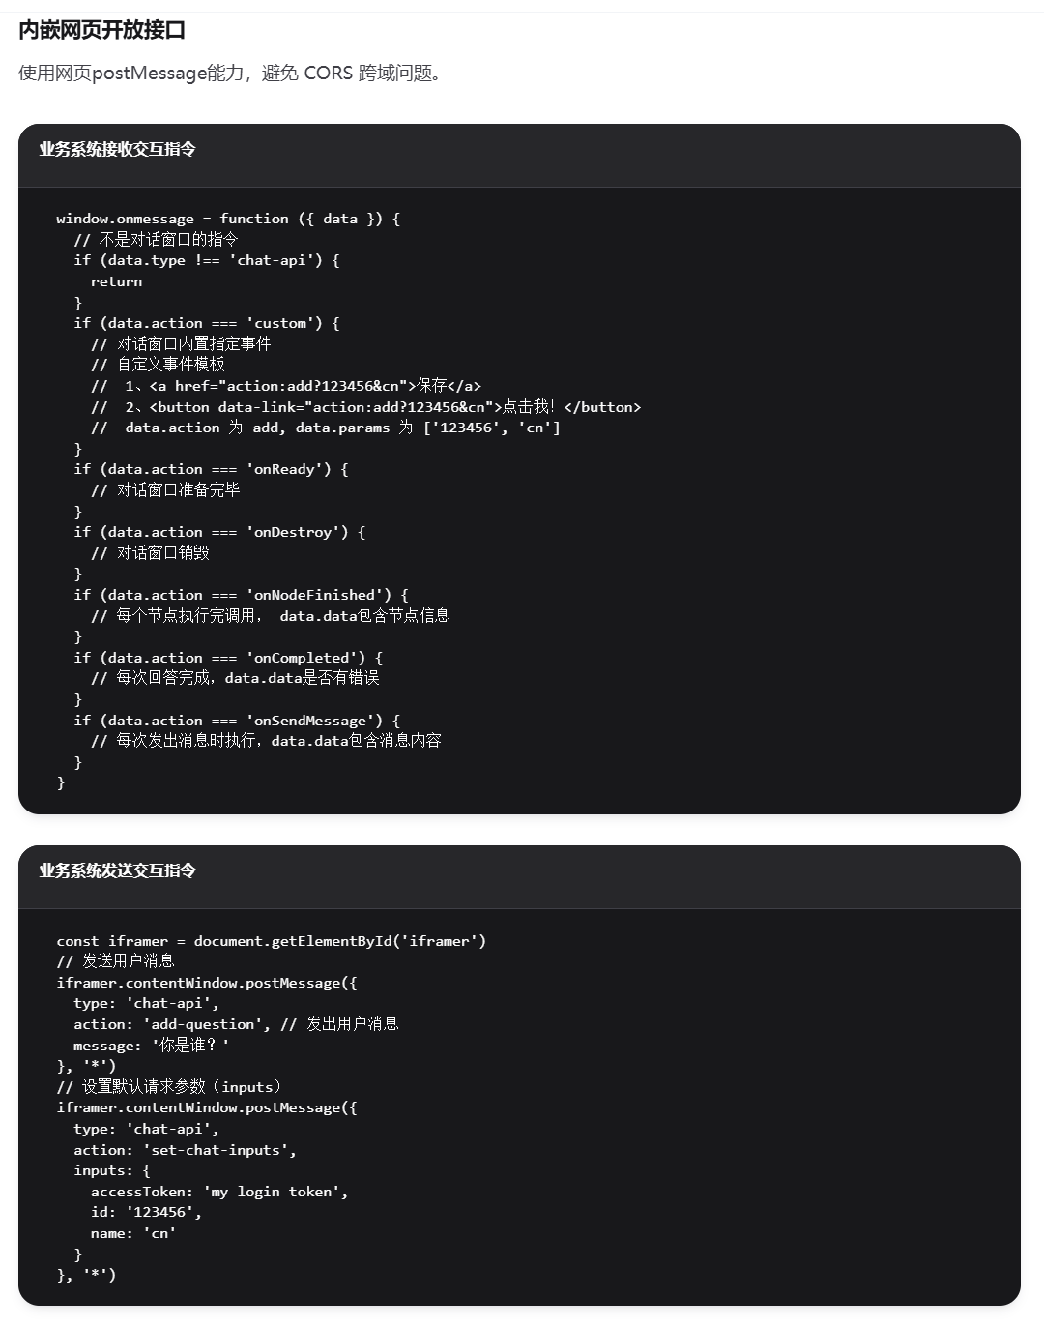
Embedded Web Page Integration API
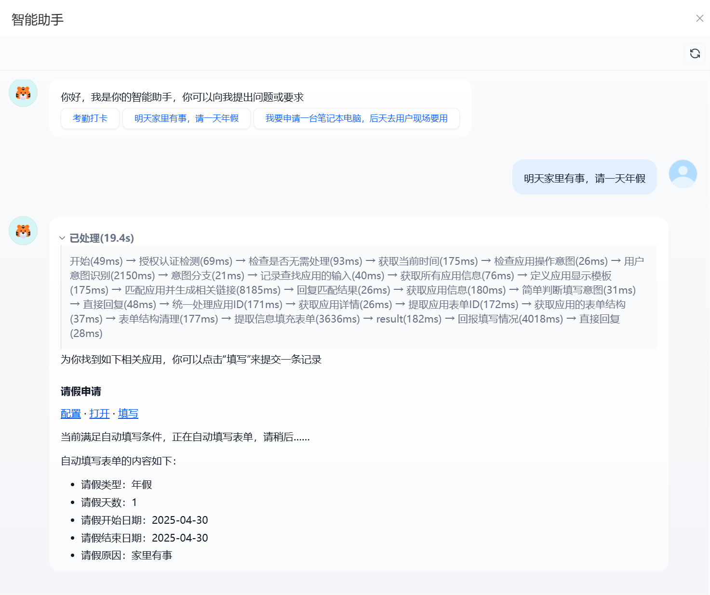
Post-Publishing Integration Example 1
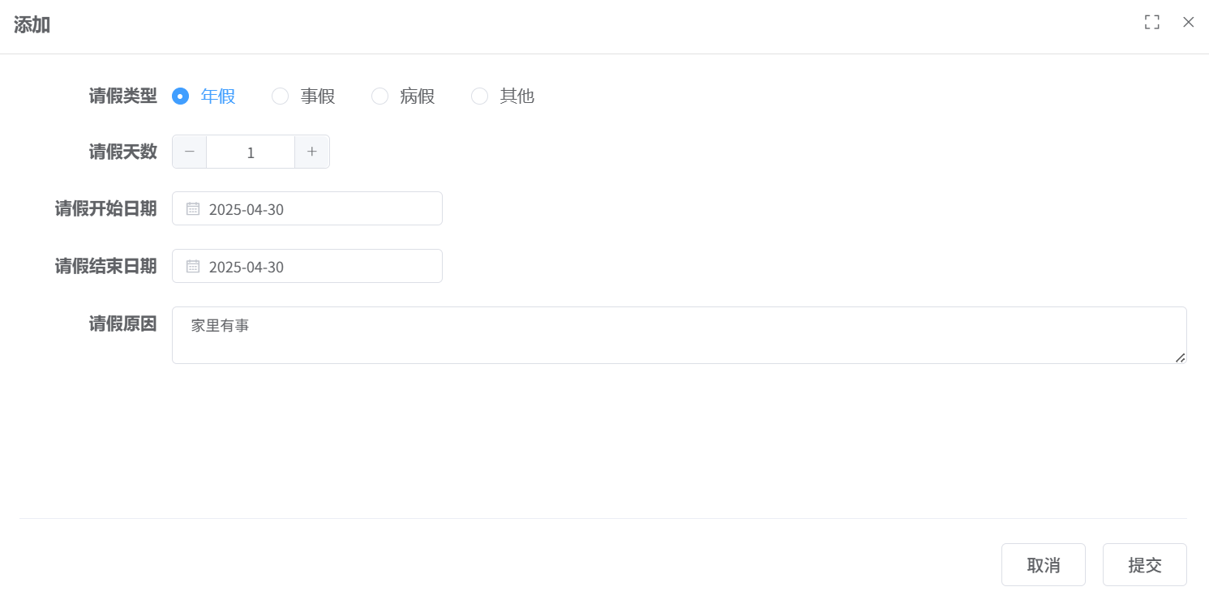
Post-Publishing Integration Example 2

